1.Describe your Target audience

Mechanic shops, Car dealerships, Manufactures, mining industry, and any sector that produces used oil. – Scope requirement additional information.

**2.What is the purpose of the website**

To create awareness of our business and services to our target market, to communicate with our clients continuously and create a space where our clients can interact with us daily. – Scope requirement additional information.

**3. What is the core values and expression to customers**

Safety, Environment, Efficiency and Proactive – Critical scope requirement additional information, all in question 3 answers.

In order for us to keep our environment safe we ensure that we offer valued added service by proactively placing 210l drums at customers to decant their oil for us to monitor and safely collect and dispose of through registered recyclers and refiners

Safety – safely collect and dispose of used oil

Environment – Offer services to collect used oil generated to dispose of safely to keep our environment safe

Efficient – We operate efficiently by using our own drum at customer to decant and collect oil for disposal

Proactive – Leave 210l drums at customer for decanting

**4. What makes you different from your competitors**

We are in the industrial Westrand area of Gauteng and we service clients around the country. Offer pro-active services for your used oil collection needs and only deliver to **ISO 14001 registered refiners and recyclers around the country. We** are overseen and audited by **NORA-SA and m**ake**data reports** available as an additional requirement of the Waste Act. Offer a **value- added**collection **service with containers provided to customers to decant oil for collection.** We also have **Public Liability Coverage** of R1 000 000 and **Spillage insurance. For yours and our peace of mind we** only hire **fully trained staff** and pay **market related prices** for your used oil. – Critical scope requirement additional information, all in question 4 answers.

**5. Do you have business specific colours you want used**

* Dark Lime Green
* Light lime green
* Musturd yellowish
* White
* Black
* Slight specific grey

– Critical scope requirement additional information, all in question 5 answers. Material design color palette styles for the following (used in below logo sample):

* Orange, Hex value: #FF9800 – hex value used for consistency
* Yellow, Hex value: #FFEB3B – hex value used for consistency
* Lime, Hex value: #CDDC39 – hex value used for consistency

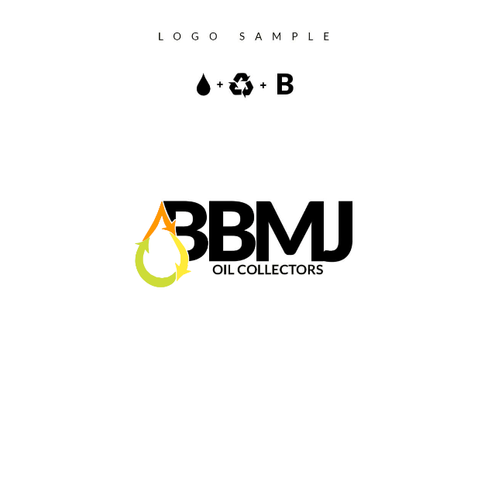

**6. Can you provide the Pantone numbers for your Business colours**

Please check slide pic for colour tone – Critical scope requirement.

**7.** **Do you have any other materials that the site needs to match with in some way (brochures, banners, business cards, etc**

Please see attached slides especially the first slide. Use that as main design of website and preferably the same pics. Example**:** <http://nigroup.co.za/>, <https://www.transittransport.co.za/>, <https://www.iwesco.co.za/> – Critical scope requirement.

**8. Describe the style of website you want**I want it to be simple and flowy and green shades mixed with black and white to draw attention to detail – Critical scope requirement.

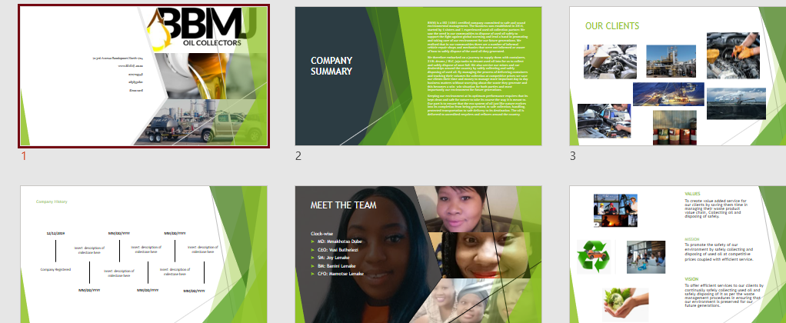

**9. What do your current competitors’ websites have that you wish to have?**

They have websites – Scope requirement additional information.

**11. Are there any websites with designs that you like?**

<http://nigroup.co.za/>, <https://www.transittransport.co.za/>, <https://www.iwesco.co.za/> – Scope requirement additional information.

**12. What about those websites would you like to be incorporated into your website?**

The moving slide (it is named a carousel) – Scope requirement additional information.

**13. What types of things do you see on other websites that you really like?**

Quick lay out: – Scope requirement additional information, all in question 13 answers.

* INTRO slide as per Bus Profile intro with (headings: Home, Company, contact on top right corner. The sliding (carousel) with pics: the vision, values, and mission statement in 1,2,3 words -<https://www.transittransport.co.za/>
* Last slide: – let words slide out of the pics from the side
* Who we are?
* What we do and how we do it?
* 3 columns of detailed vision, mission, and values
* The sharp lines and the white spaces
* Its not clattered.

**14. What types of things do you see on other websites that you really hate?**

Too much information – Scope requirement additional information.

**15. Name the 3 things that are most important in the design of your new website.**

Sleek and professional, no clutter, use of colour wisely, NB info first and highlighted cleverly – Critical scope requirement.

**16. Name the 3 things that are least important in the design of your new website.**

Complications – Scope requirement additional information.

**17. Where is your current domain (http://www.examplebusiness.co.za) hosted, if you have one?** NA – Critical: It is the business’ unique and professional identity. Check the below brief example:

Example Domain / Website Address: <https:///www.examplebusiness.co.za/>

Your Business Domain / Website Address: <https:///www.yourbusinessdomain.co.za/>

Therefore: <https:///www.bbmj.co.za/> or <https:///www.bbmj.com/>

**Domain** = bbmj.co.za **or** bbmj.com

I have lenake.tech and lenake.co, besides my personal domain (onkgopotselenake.me) in which it is a perfect example that I am referring to with unique professionalism. Either of the two Lenake domains can be used by your business as being a sub-domain. Customers consider a business as being professional when they see the above, while searching for services online. We can discuss this further for more information.

**18. Do you have full access?** NA

**19. Can you provide usernames and passwords?** NA

**20. How much are you paying for the domain?** NA

**21. How long does it take to renew your current domain hosting subscription and how much?** NA

For questions 18 to 21, all refer to the points mentioned in 17. Further discussions for more information.

**22. Who will be involved on your end in the development of the website?** Mmakhotso

**23. Any other contractors (Photoshop picture creators, editors, logo designers and any other)?** NA

**24. Who or how will you be managing website upkeep? B: Scope & Specs -**You

**25. Do you require a database?** If possible, oil industry data base

**26. What specific functionality will it need?** NA

For 25 and 26, they refer to a database design and its process. This is another aspect and we can check it out at least after the initial high-level requirements mock-up of an example website. I am thinking about its process too though, while designing the initial mock-up (sample website and flow).

**BUSINESS SCOPE**

**1. Does your current domain host meet all your domain’s hosting needs and what are those needs? NA**

**2. Do you plan on to move to a new host provider? NA**

**3. Can you provide the original artwork files of your logo? NA –** These are the vector files that I was referring to and asking you about regarding the design of the logo. I have started to create these too – another animal.

**4. Do you have the content for the website or will content creation be a part of the scope of work? T**here is content attached

**5. How many pages of content will need to be developed?** 2**-**3 Maximum

**6. Will there be any cross promotion of content within the site?** Not currently

**7. Please provide details on content cross promotion.** NA

**8. Do you or your team need training for making website updates, content publishing guidelines, etc.?** Yes – We will check this with time, and I will show you guys how you can do this.

**9. What types of actions do you want your visitors to take on your website?** Request quotes via fill in’s or contact details. – Critical scope requirement.

**10. Where/which pages do you plan that the sent photos be used?** Throughout the pages. – Scope requirement.

**11. Will I need to find and/or create any images for the website?** All attached provide step by step slide design with notes and direction on imagery of sliding paragraph from the pictures (2nd slide), pics for fist slides with word descriptions 00of vision, mission and values. – Critical scope requirement.

**12. Will video or audio be a part of the new website?** NA

**13. Can you provide me with the proper files or is creation of this content part of the scope of work?** All attached – Scope requirement.

**14. How many videos or audio files will be added and/or created?** NA

**15. Will any customizations need to be made as optimizing for search, adding content overlays, customized wrappers, etc.?** Not necessary. – Maybe critical scope requirement. Must check further with more analysis. It is critical for Search Engine Optimization (SEO – mainly a strategy for marketing) that is used and loved by internet search engines. Examples search engines: Google, Bing, Yahoo etc.

**16. Do you require online chat features?** NA

**17. Do you have any other media or PDF documents that need to be incorporated, or will any need to be created?** Not currently – Future roadmap.

**18. Will these need to be optimized for search?** Not Currently – Future roadmap.

**19. Will your visitors require any special needs (i.e., screen reader ready, larger fonts)?** NA – Critical scope requirement mainly for website accessibility that is focused especially on people who are disabled. They do have screen readers, larger fonts etc., device features designed for them.

**20. Do you require your site to be mobile friendly (responsive design)?** If possible, please – Critical scope requirement as the standard today is going towards mobile first website design.

**21. Do you have any specific mobile requirements?** NA – Possible future roadmap.

**22. Do you need multi-language support? NA** – Nice to have.

**23. Will you need multiple levels of access on your content management system (CMS)?** Yes, just 1 extra – Security feature requirement.

**24. Do you need to be able to manage content publishing approval processes? NA** – Possible future roadmap.

**25. Does your site need a blog or a forum? NA** – Possible future roadmap. Might help with some sought of FAQs if that need arise.

**26. Will users need to log in to your site for any reason? NA**

**27. If so, why? NA**

**28. Do you need any password protected areas for your website? NA**

**29. What kind of content will be put behind password protected areas? NA**

**30. How many web forms (e.g. capture new customers, any others) does your new site need? NA**

**31. What is the purpose of each? NA**

**32. How do you want the submitted info handled? (email, database, etc.) NA**

**33. Do you need any social sharing features built in (tweet, like, +1, share, etc.)? tweeter, FB** – What are the social accounts profile names to enable these features?

**34. Will there be any third-party applications that will need to be integrated (e.g. your apps)? NA**

**35. What are they (applications used by your business)? NA**

**36. Will you need an events calendar feature? Yes** – What is the events calendar’s account profile or application integration points? Will discuss this point further.

**37. Do you have any subscription service? NA**

**38. Do you use a third party for any part of subscription content delivery and/or payment? NA**

**39. Do you require printer friendly options for printing services**? If possible, add for future – Future roadmap.

**40. Do you wish to employ any “content-on-demand” features (i.e., hidden elements that are made visible with certain actions)?** Yes – Vision, Mission, statement elaborations – Do not worry too much about this one. Requires specialised skills and not required for now. Mainly for marketing. The points that you are referring to will be covered above.

**41. Do you want a fixed-width or fluid-width design?** Fluid Width– Will be covered by responsive design with mobile first approach.

**42. What information must be on the home page?** About business, contact info (content attached) – Critical scope requirement.

**43. What information must always be visible?** Slogan, contact, mission vision and value slides – Critical scope requirement.

**44. What features, sections or information do you want emphasized on the site?** The slogan, vision, mission, contacts – Critical scope requirement.

**45. How would you like that to be featured?** Vision, mission and values sliding slides, contacts in dark colour against white background – Critical scope requirement.

**46. Will different sections of your site require different designs, layouts, or colouring? Not** Necessary…carry out one theme of main white, shades of dark and light lime green and writingmainly in black – Critical scope requirement.

**47. Do you have any flash (played by flash player) elements you want included? NA**

**48. Will those be provided, or do they need to be created?** NA

**49. Do you need an internal site search feature?** NA – Future roadmap.

**50. Do you want contact phone numbers prominently displayed?** YES – Critical scope requirement.

**51. Will you be offering advertising on the site?** NA

**52. How should that be implemented?** NA

**53. Do you have a Google Analytics account (analyses how many site visitors, how many did what)?** NA

**54. Can you provide us access?** NA

**55. Do you have any other specifications or need specific functionality that has not been addressed?** NA

**56. Will you be looking for keyword optimization beyond the design/development scope? C: Project** NA

**57. What does a success for this project look like to you?** Simple and professional website – Excellent.

**Critical Questions / Project Brief Review**

Review of the document going towards the **initial website requirements specifications** document.

Feedback highlighted in grey and yellow to identify scope.

Feedback written / highlighted in red to identify concerns that need further discussion.